Tutorial – Week 12
White-box Testing

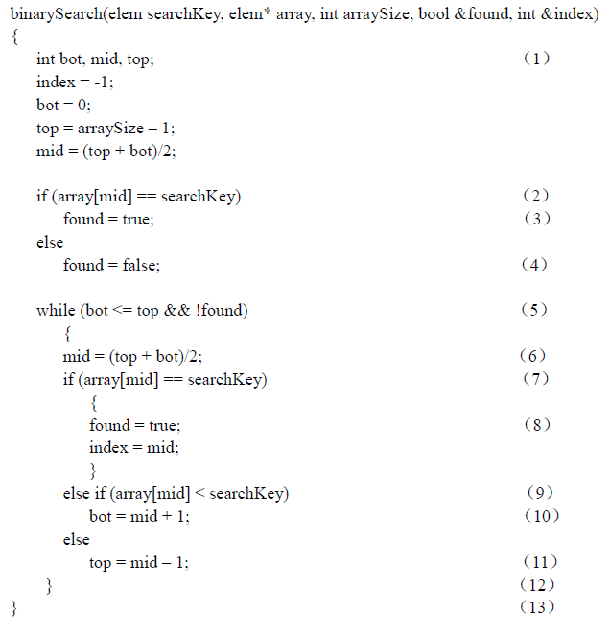

The above is a binary search function written in C language. Answer the following questions base on the code.

Question 1
Draw a control flow graph corresponding to the preceding function.

Question 2
For the preceding function, derive a set of test cases that will cover branch testing.

Question 3
Design additional test cases that will cover multiple-condition testing.

Question 4
Determine the cyclomatic complexity of the preceding function.

Question 5
Derive a set of test cases that cover McCabe’s Basis Paths.

